Using DBCA to Create a New Database

The following outlines the steps followed in order to create a new database on an Azure server.

Make sure that the user you are logged in as is a member of the oracle group.

Please note: Where screen dumps are displayed, they are displayed below the (set of) instructions that have been executed already to configure the screen as shown in the image. (Except for clicking "next" etc to move to the next screen.

Also note that your eyes are not failing, those screen shots really are out of focus. Don't ask, Windows does that sort of thing sometimes!

Build the Default Database
The database should be created first, as a default general purpose database. The following steps take you through the use of DBCA.bat, to create the initial database.
- Right-click on the start button on the server, and select search.
- On the far right, type dbca.bat, the search takes place as you type.
- When it appears, right click on dbca.bat and select "run as administrator" this is very important. Confirm your desire to do so when prompted.

There are 12 screens to pass through before you can get a new database.

- On the Welcome screen, click next.
- Select "Create a Database", click next.
- 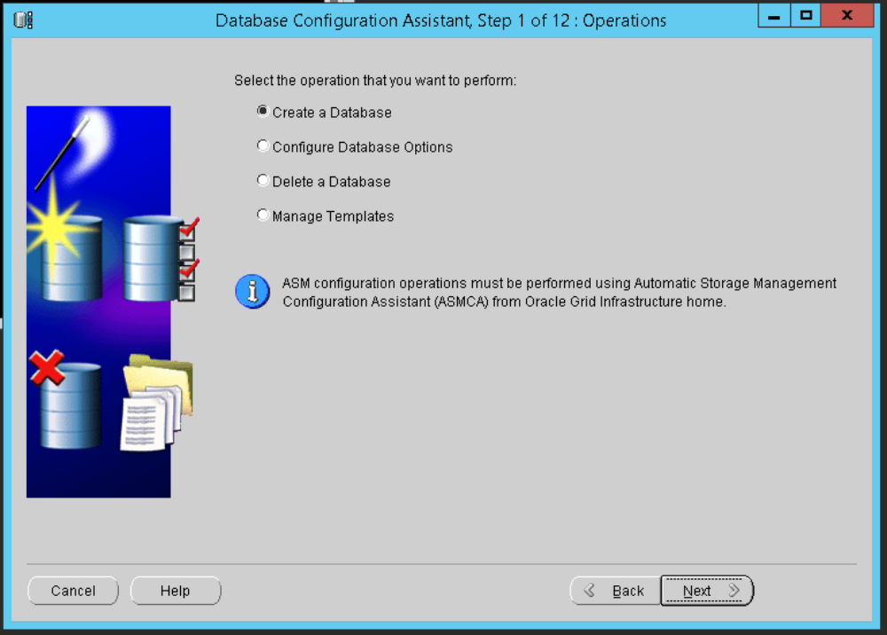
- Select "General Purpose or Transaction Processing" and click next.
- 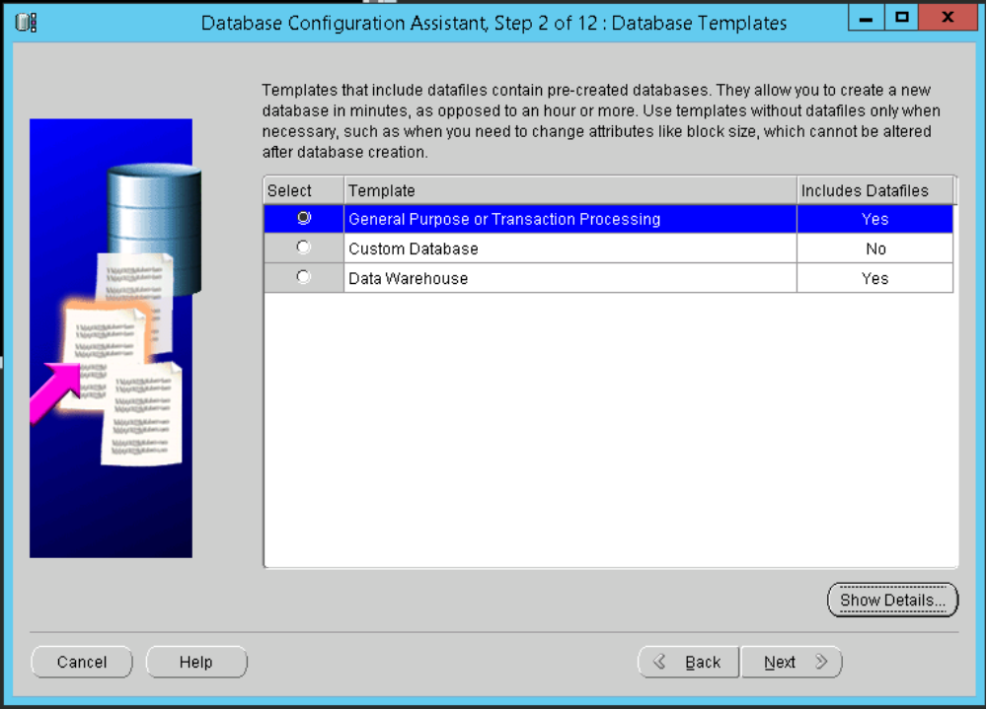
- Enter the Global Database name, and the same for the SID. Click next.
- 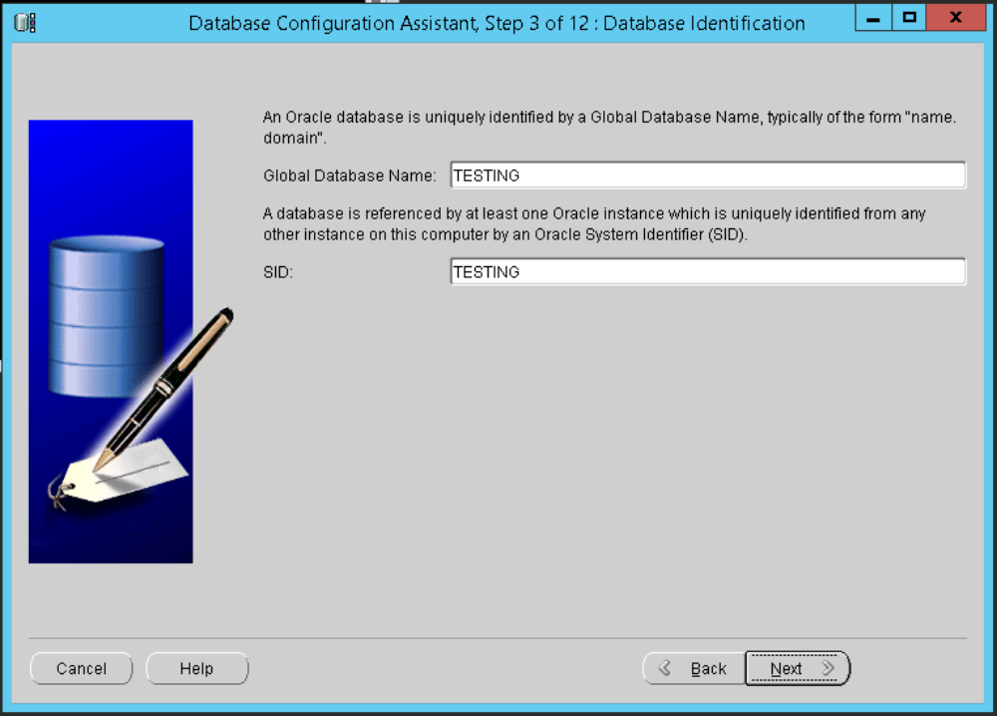
- Deselect "Configure Enterprise Manager", click next.
- 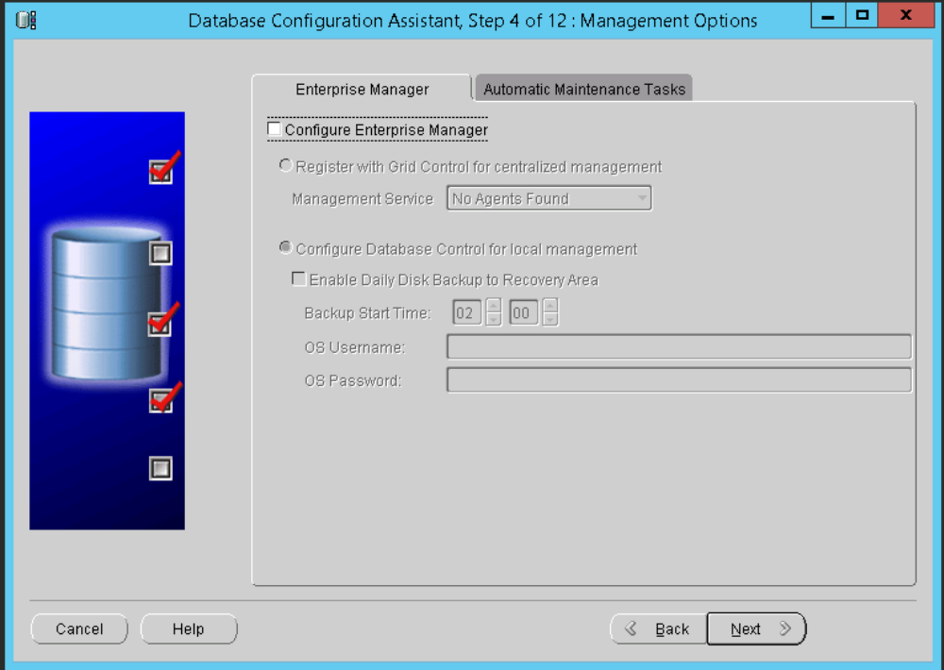
- Select "use same password …" then enter and confirm the desired password to be used for SYS and SYSTEM. Click next.
- 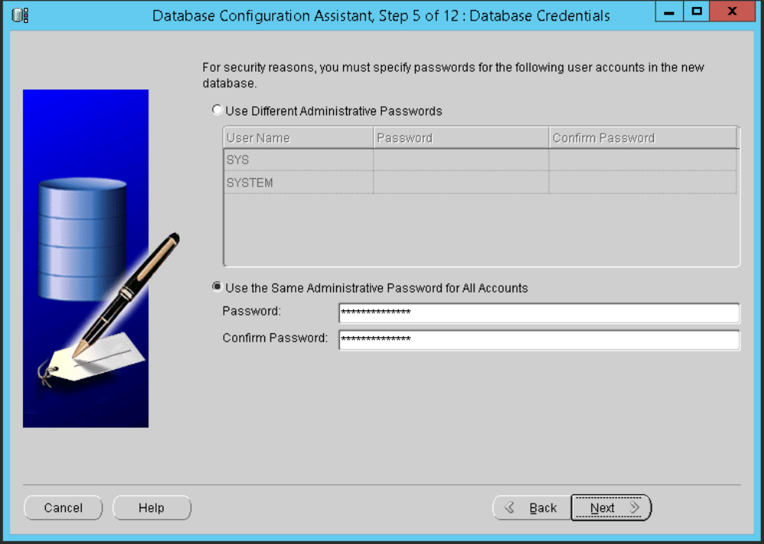
- Select "use common location for all database files".
- Either type the desired drive and path & click next, or,
  - Click browse.
  - Select the correct data drive in the drop down at the top.
  - Select the \mnt\oradata folder.
- Click OK. Confirm when prompted. Click Next.
- 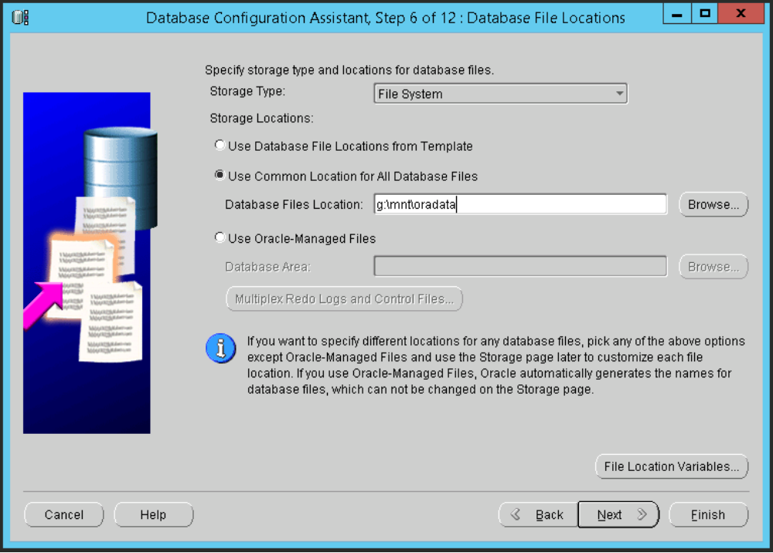
- Either type desired FRA path, or,
  - Select "Specify Fast Recovery Area". Click browse.
  - Select the correct data drive in the drop down at the top.
  - Select the \mnt\fast_recovery_area folder.
  - Do not amend the Directory path at the bottom. Click OK.
- If necessary, Change the Fast Area Recovery Size to a suitable size and ensure MBytes is selected.
- Deselect "enable archiving" for now. Click next.
- 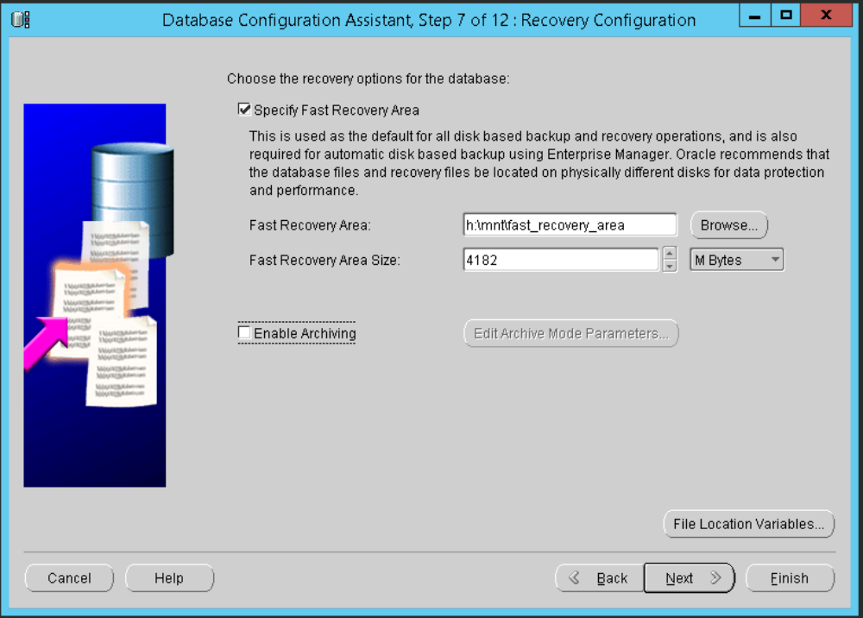
- Confirm the fact that the FRA size is too small. (If prompted.)
- Deselect "Sample Schemas". Click next. (This will still create the SCOTT schema.)
- On the tabs:
  - Memory: Leave size as defaulted.
  - Memory: Select "Use automatic memory management"
  - 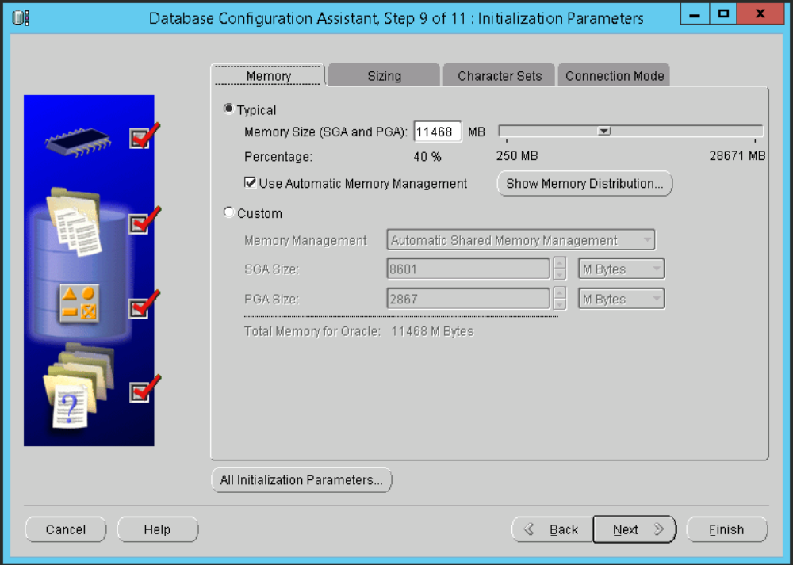
  - Sizing: No changes required.
  - Character Sets: Select "choose from the list …"
  - Character Sets: Deselect "Show recommended …"
  - Character Sets: Select "WE8ISO8859P1" from the drop down.
  - NLS Character Set: Should already be correctly set to AL16UTF16.
  - Character Sets: Choose "American" as the default language.
  - Character Sets: Choose "United States" as the default territory.
  - 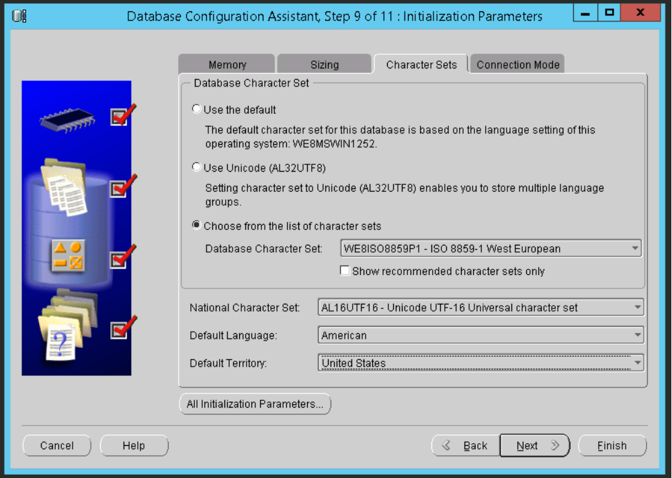
  - Connection Mode: No changes required.
  - Click next
- Click on controlfile then make sure that there is one file created in "?:\mnt\oradata\{DB_UNIQUE_NAME}\" and the other in "?:\mnt\fast_recovery_area\{DB_UNIQUE_NAME}\". A third will have a path but no name. This is fine.
- 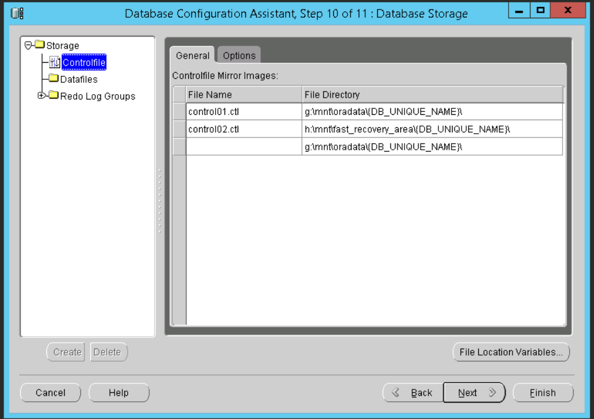
- ONLY change the redo logs groups if you are not intending to convert this default database to a UV full sized database. If so, there are separate instructions in the appropriate document for this.
  - Click the '+' beside Redo Log Groups.
  - For each of the 3 options, 1, 2 and 3, click it.
    - Change the name to Redo0?a.log where '?' is 1, 2 or 3.
    - For each redo file listed, ensure the path is "???:\mnt\oradata\{DB_UNIQUE_NAME}\" where '???' is the correct drive letter.
  - For each of the 3 options, 1, 2 and 3, click it.
    - Add a second logfile where the name is Redo0?b.log where '?' is 1, 2 or 3, to the second line. Beware, Oracle will try to add ".ora" to the end. Delete it.
    - Make sure that the path is set to "???:\mnt\fast_recovery_area\{DB_UNIQUE_NAME}\". (? is the correct drive obviously!)
  - Click next.
- 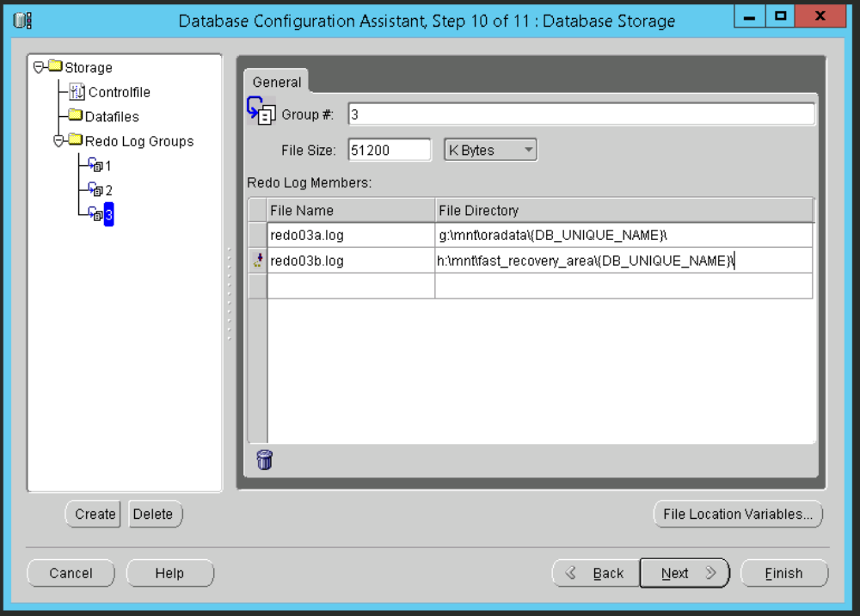
- Select Create Database.
- You may, if you wish, create a template if you need to create another database like this one in future. It's not worth it though. Oracle changes/defaults far too much of what you entered, so you'll end up changing everything again.
- Select Create database Creation Scripts though. This is useful and will save you running through all this again, if required. Leave the Destination Directory as per the default.
- Click finish.
- 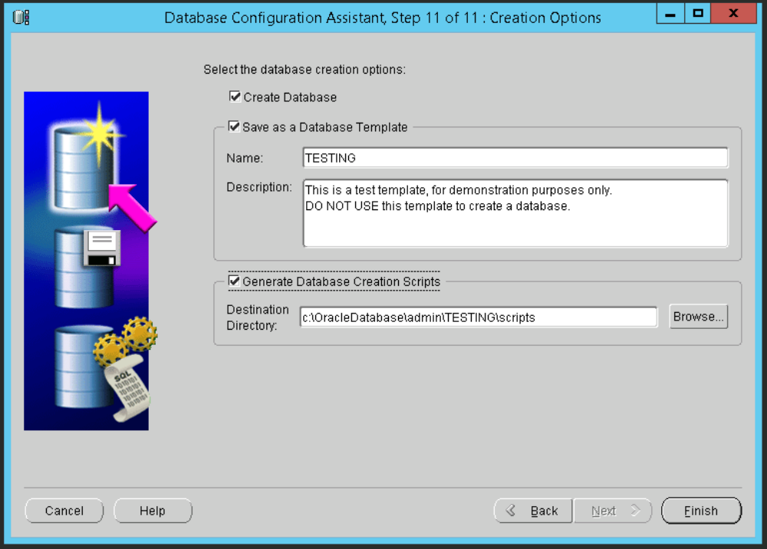
- Click OK on the confirmation screen.
- Click OK to confirm that the script creation was ok.
- The database will start to build. Wait ….
- Click Exit when give the opportunity to do so.

Run the Post Build Scripts
After a blank database has been created, we must run the various scripts to make it look like our own database. The scripts are in TFS at the following location:

$/TA/DEV/Projects/Oracle Upgrade 9i to 11g/UKRegulated/Database/DBA Documentation/Code/TrialRunStuff

The description of how and why these must be executed are to be found in various documents in the following TFS location:

$/TA/DEV/Projects/Oracle Upgrade 9i to 11g/UKRegulated/Database/DBA Documentation/Build Documents

For example, the post build details to convert this default database to a UV database are found in the document "01 AZURE - Building databases after DBCA creation.docx".

Be aware that if the post build scripts etc are not executed correctly, any attempt at importing from migration dump files will fail. Badly!

